**Lab report #2**

**Sadovskaya Veronika**

GitHub: https://github.com/sdveronika/DataMola22

**Task 1 - CREATE Daily Reports Layouts**

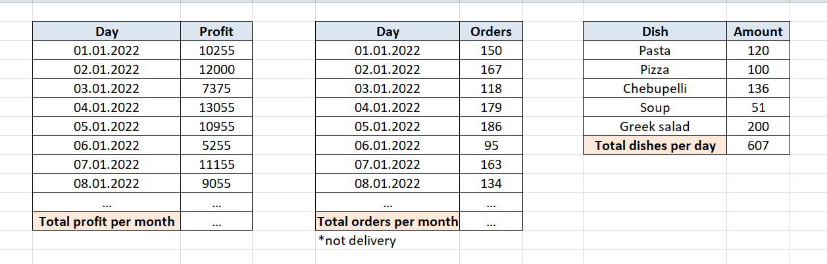

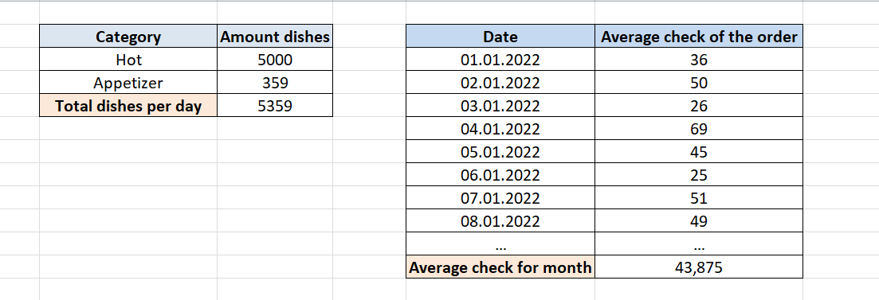

**Task 2 - CREATE Monthly Reports Layouts**

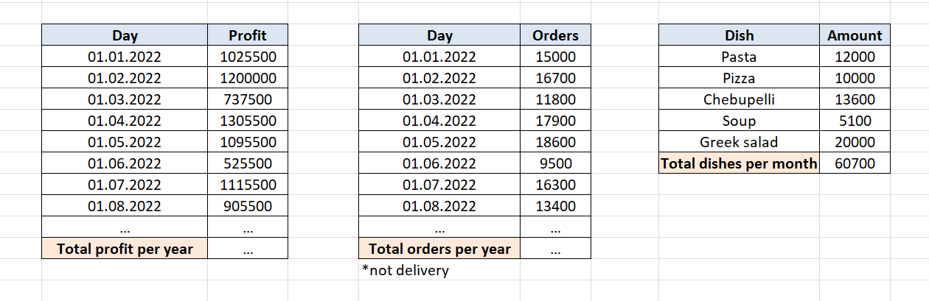

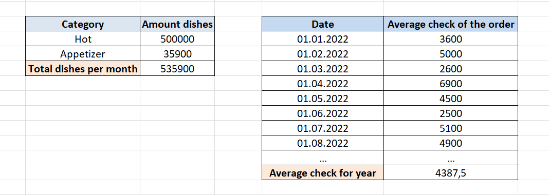

**Note:** tasks 1 and 2 present the simplest examples of results, to which you can add grouping by country, region, city, delivery, or order payment method.

**Task 3 - CREATE Test AdHoc SQL - Daily Reports (CUBE)**

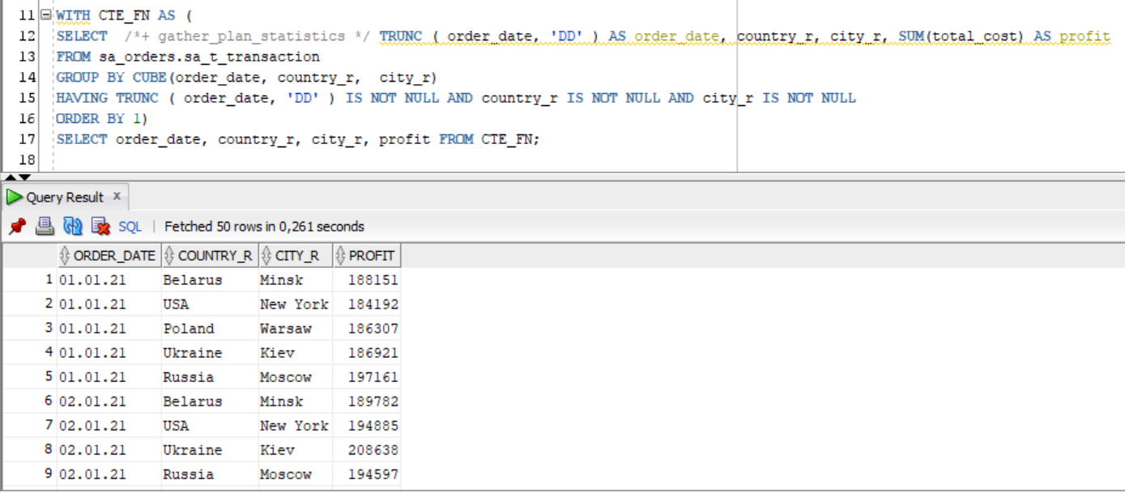

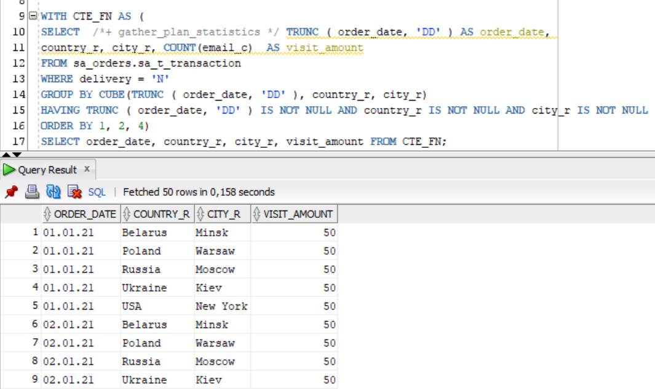

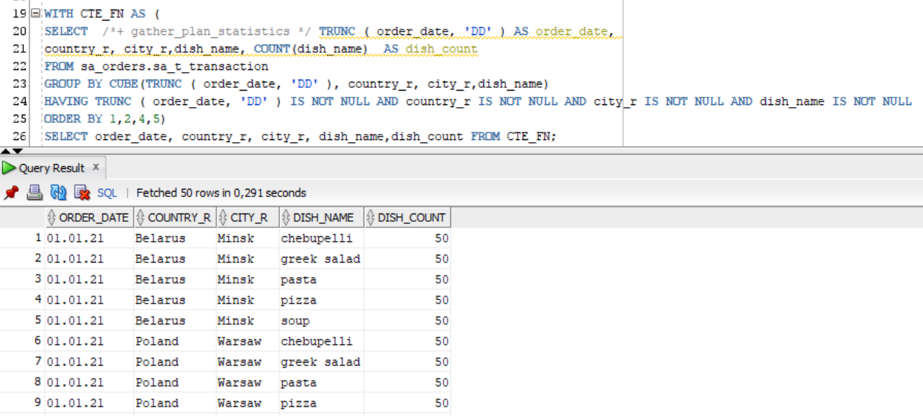

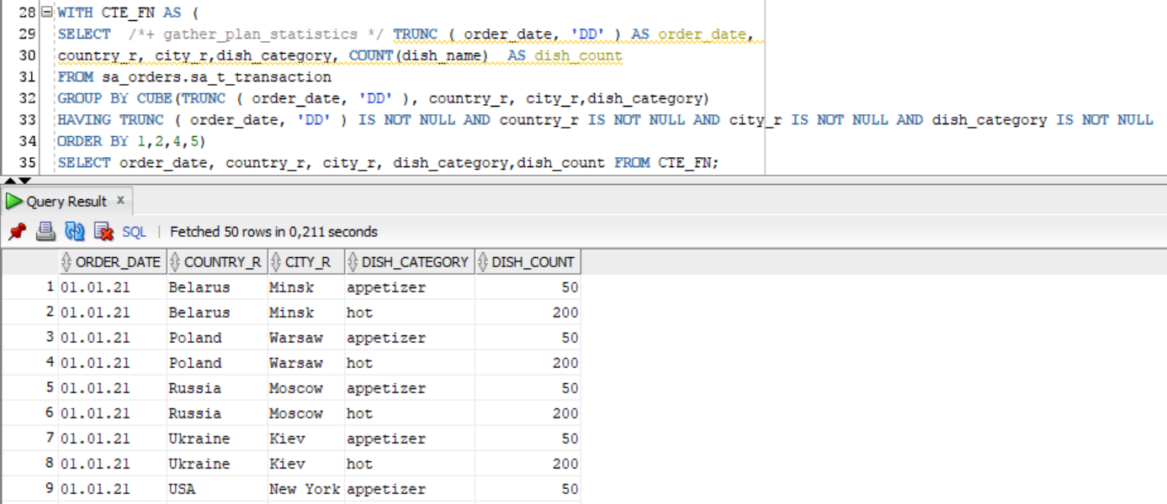

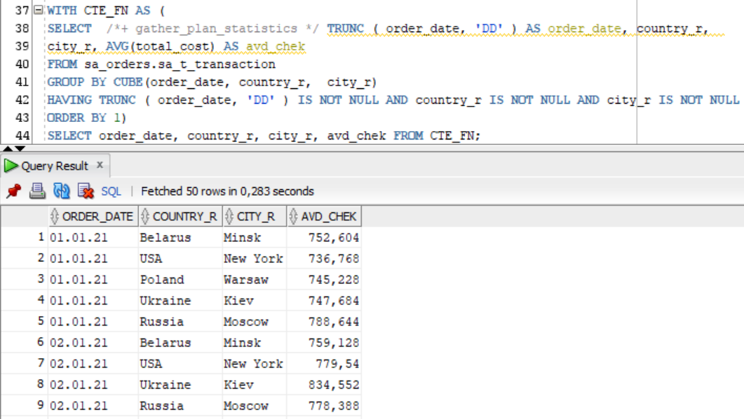

**Task 4 - CREATE Test AdHoc SQL - Monthly Reports (****ROLLUP & GROUPING SETS)**

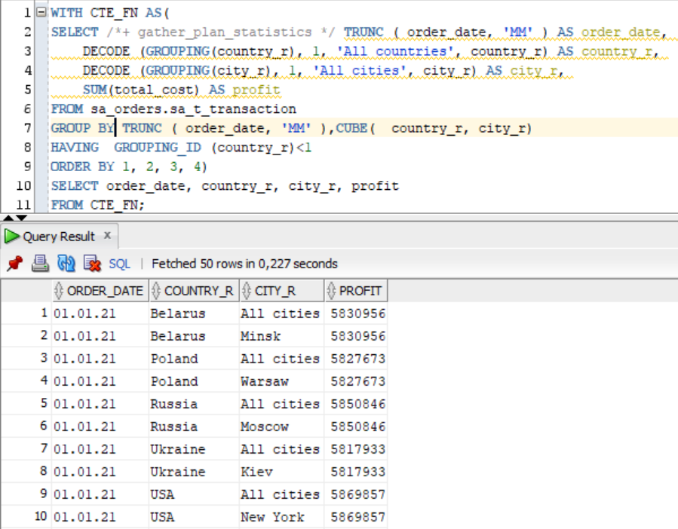

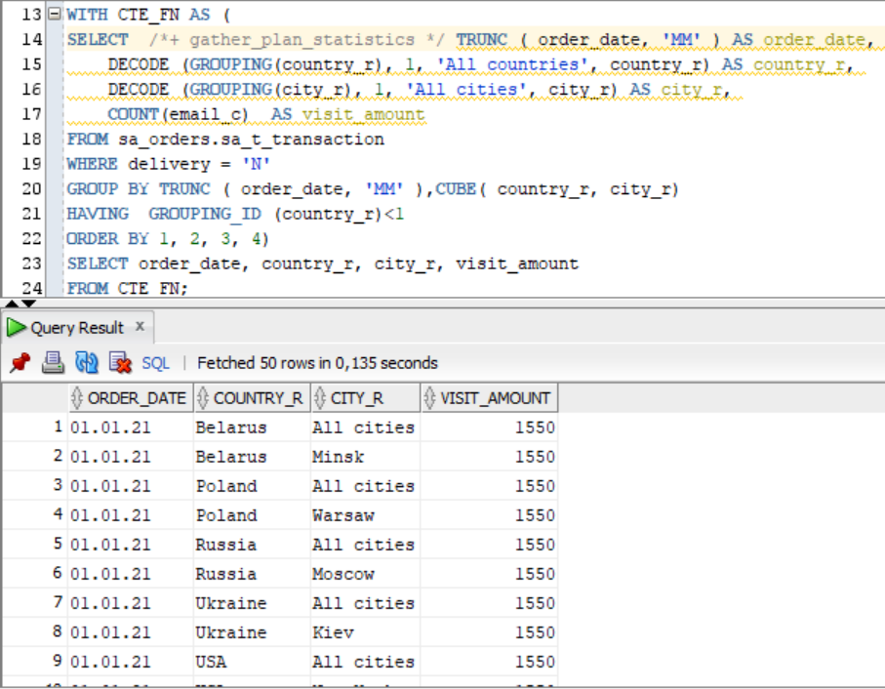

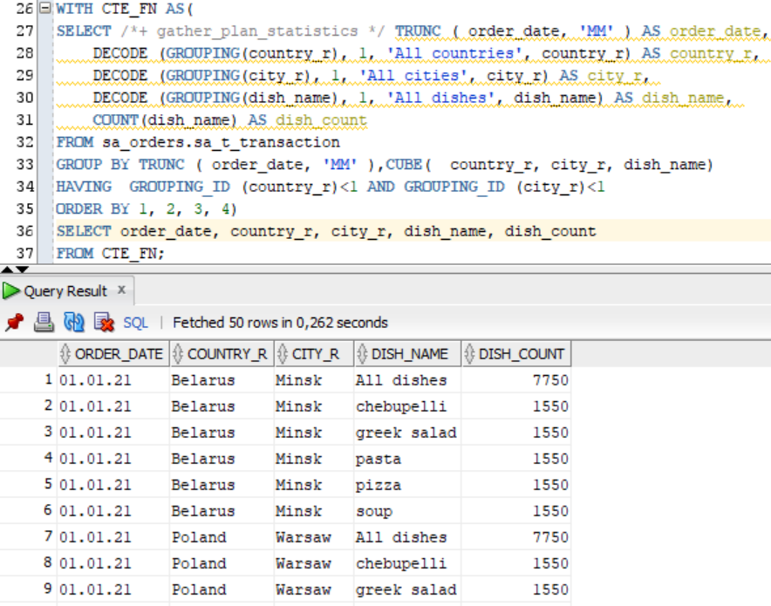

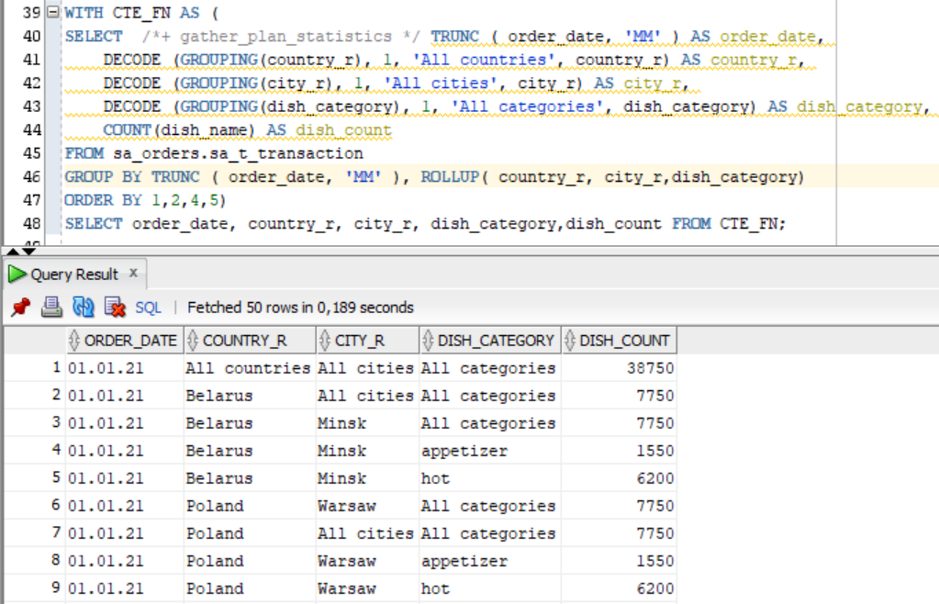

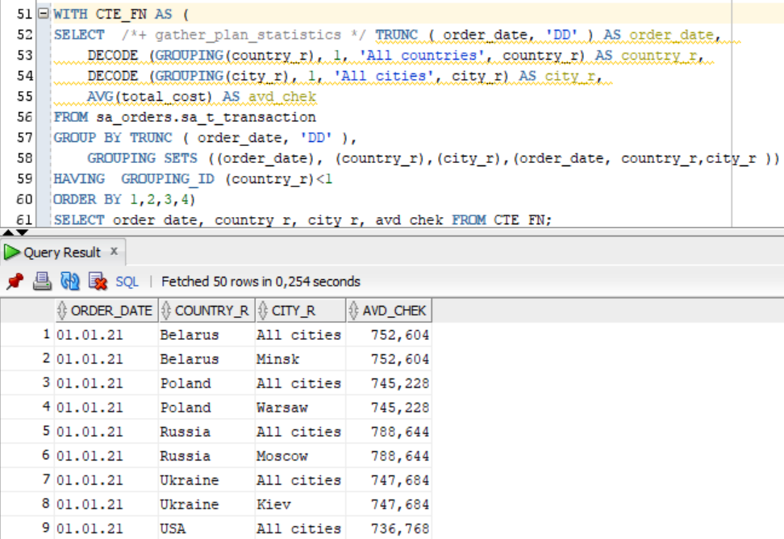

**Task 5 - CREATE Test AdHoc SQL – ROLLUP by Time**

